

Insights | Pages
Textile Industry- Global and India | 3-9
Welspun India- Business and competition | 10-17
Textile Manufacturing process | 18-58
Positions in Textile industry | 59

Content

Textile –Global
- The textile industry or apparel industry is primarily concerned with the design and production of yarn, cloth, clothing,
and their distribution. The raw material may be natural, or synthetic using products of the chemical industry.

- The current global garment market is approximately US$ 1.15 trillion which forms nearly 1.8% of the world GDP. Almost 75% of this market is concentrated in EU‐27, USA, China and Japan.

- China is the largest textile producing and exporting country in the world.

- In 2014, China’s textile exports were valued at just over 110 billion U.S. Dollars.

- The world garment market is growing at a CAGR of 5% and attaining a size of about US$ 2.21 trillion by 2025

- Textile and Clothing nominal sales ceded -4% in 2015 and were crippled by unusually low commodity prices (cotton - 15%, wool -7%, and manmade fibers 1%) and multiple currency depreciations worldwide, particularly in emerging markets.

Source: : World Statistics , Textile Ministry, Make in India, TechSci Researh
Note: Figures are as per latest data available

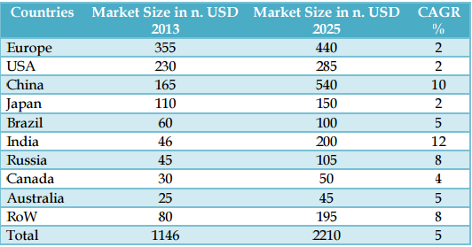

Textile – India on Global Stage
- According to UN Comtrade data released in June, 2014
India was announced as the world’s second largest exporter of textiles and clothing in the world
And 6th largest exporter of clothing only

- India is the 2nd biggest producer of silk and cotton

- Indian textile industry accounts for about 24 per cent of the world’s spindle capacity and 8 per cent of global rotor capacity

- India has the highest loom capacity (including hand looms) with 63 per cent of the world’s market share

- India accounts for about 14 per cent of the world’s production of textile fibres and yarns (largest producer of jute, second largest producer of silk and cotton; and third largest in cellulosic fibre)

Source: Textile Ministry, Make in India, TechSci Research Note: Figures are as per latest data available

Key Facts- Textile in India
The fundamental strength of the textile industry in India is its strong production base of wide range of fibre/yarns from
natural fibres like cotton, jute, silk and wool to synthetic /man-made fibres like polyester, viscose, nylon and acrylic.

- Textile contributes to 3-4% to country’s gross domestic product.

- 17% to country’s export earnings come from Textile.

- Provides direct employment to over 35 million people in India.

- It is the largest provider of employment after agriculture.

- India earns about 27% of its total foreign exchange through textile exports.

- The textile industry of India also contributes nearly 14% of the total industrial production of the country.

- Among the countries, Japan, Australia and New Zealand are the significant consumers of Indian textiles.

Source: Textile Ministry, Make in India, TechSci Research Note: Figures are as per latest data available

The Sector Has Been Posting Strong Growth Over The Years

  - Textile plays a major role in the Indian economy

  - It contributes 14 per cent to industrial production and 4 per cent to GDP

  - With over 45 million people, the industry is one of the largest source of employment generation in the country

  - The size of India’s textile market in 2014 was USD99.0 billion which is expected to touch USD226 billion market by 2023 at a

250

200

150

100

50

0

India's textile market size (USD billion)

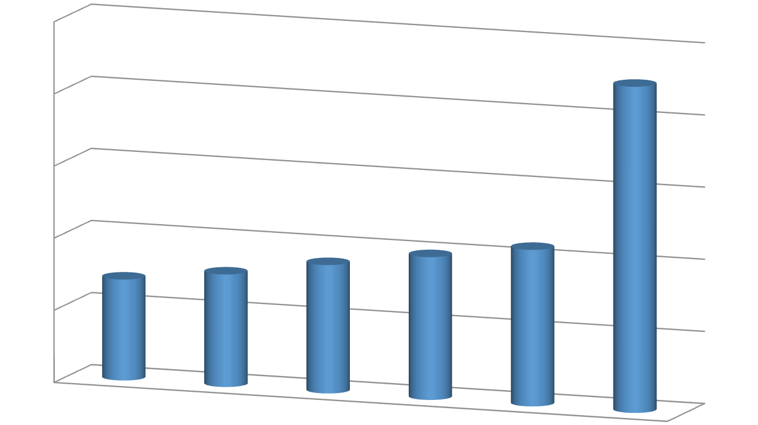78 89 99 108.5
70

2009 2010 2011 2014

226

CAGR of 8.7 per cent between 2009-23E
2015 2023E

Source: Textile Ministry, Make in India, TechSci Research Note: Figures are as per latest data available

TEXTILE INDUSTRY
Organised/ Centralized mills sector
Unorganised/ Decentralized mills sector

- Spinning Mills
- Composite mills (Spinning and weaving)
- Hand Looms
- Power Looms
- Hosiery and Khaddi units
- Processing units

SEGMENTS

Indian textile industry can be divided into several segments, some of which can be listed as below:

    - Cotton Textiles
    - Silk Textiles
    - Woollen Textiles
    - Readymade Garments
    - Hand-crafted Textiles
    - Jute and Coir


WELSPUN INDIA: WORLD’S LARGEST HOME TEXTILE COMPANY
- Welspun India Ltd. (WIL) is a fully integrated home textile manufacturer.

- It is one of the largest global home textile players, with world class manufacturing facilities in India.

- Ranked 1st in the Top 15 Supplier Giants (USA) by Home Textiles Today Magazine, January 2013.

- Anjar facility is the largest home textiles facility in Asia.

- International operations has been the major part of the revenues.

- Innovative products accounted for 31% of the revenues

- Increased vertical integration for yarn and fabric to ~70%

WELSPUN BRANDS



Premium brand with presence in India and Middle East. Footprint of over 200 shop-in-shop outlets and distribution
Largest terry towel brand in the UK with growing presence in China and the Middle East
Present in over 40 retailers within UK
Also present in USA and seeing aggressive growth in e-commerce

Mass brand presence via mass retailers; also growing via distributor
network

Mass brand in the UK with a focus on bedding Growing aggressively in affordable fashion

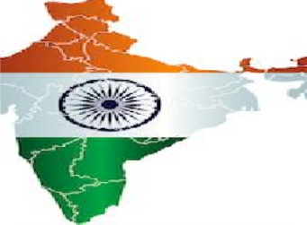Biggest Client Across Globe



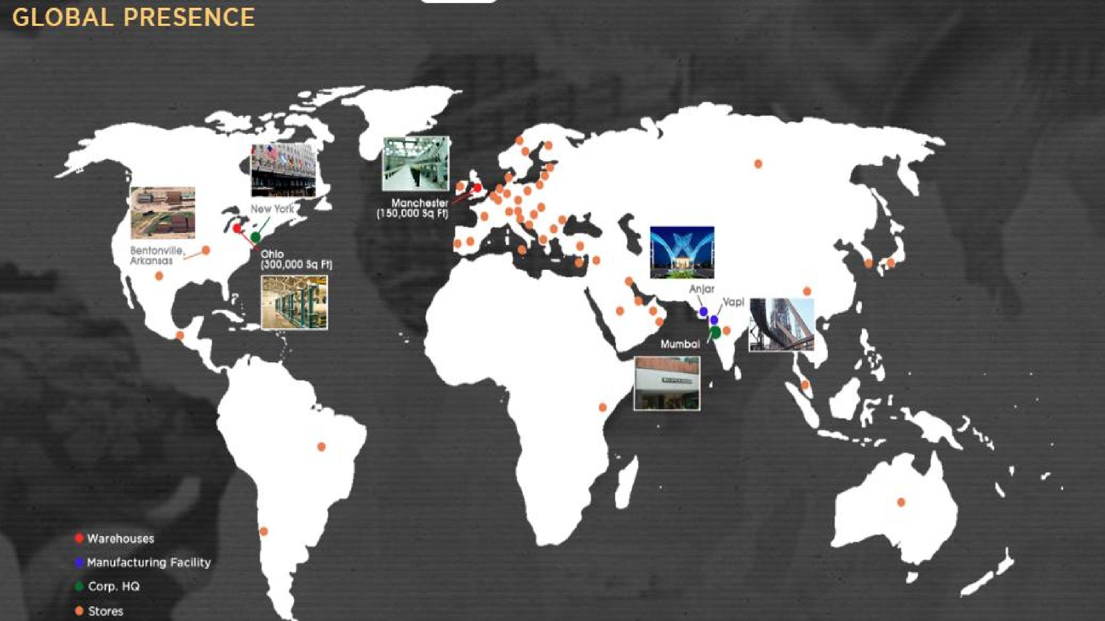

WELSPUN INDIA: WORLD’S LARGEST HOME TEXTILE COMPANY
.


Global brand
Wide Distribution network
Growth strategy
Association with top brands and clients
Focused Approach on home textiles
Focus on Innovation
Terry towels

Capacity – 50,000
MT/Year
Location - Anjar/Vapi
Capacity utilization - 102 per cent
Bed linen products

Capacity – 60 million metre/Year
Location - Anjar
Capacity utilization - 97 per cent
Rugs
Capacity – 15,000
MT/Year
Location - Vapi
Capacity utilization - 58 per cent

WELSPUN INDIA: WORLD’S LARGEST HOME TEXTILE COMPANY
- Welspun ranked 1st in home textile supplies to US

- Company exported 97 per cent of the production in FY15

- During FY10-15, revenue of Welspun increased at a CAGR of 12.2 per cent in USD terms
- During FY10-15, EBITDA of Welspun increased at a CAGR of 24.2 per cent in USD terms

1000
800
600
400
200
0

Revenue USD Million

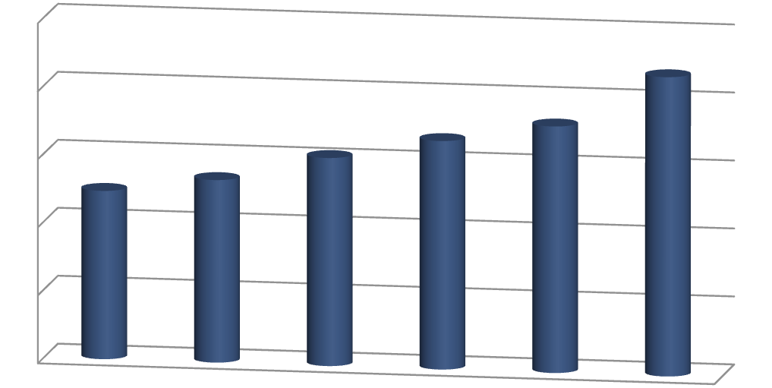CAGR 12.2%
612 672 725
495 537

880

250
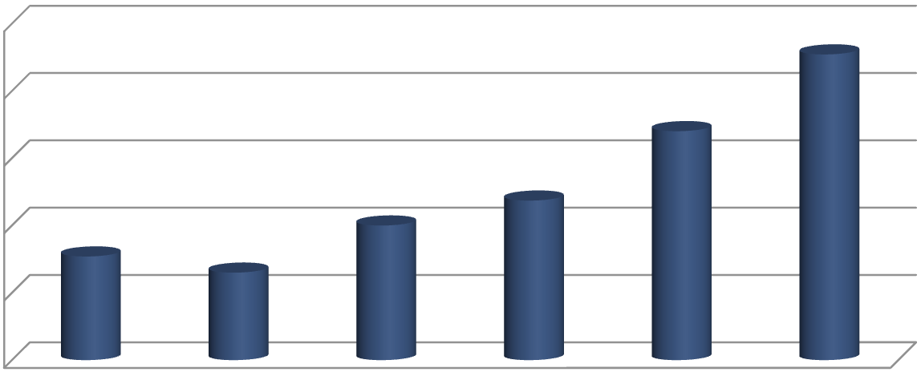200
EBITDA (USD million)
227.12
CAGR
24.2%
170.09
77
100
118.54
65
150
100
50
0

FY10 FY11 FY12 FY13 FY14 FY15
FY10 FY11 FY12 FY13 FY14 FY15

Company | Business areas
Welspun India Ltd | Home textiles, bathrobes, terry towels
Vardhman Group | Yarn, fabric, sewing threads, acrylic fiber
Alok Industries Ltd | Home textiles, woven and knitted apparel fabric,
 | garments and polyester yarn
Raymond Ltd | Worsted suiting, tailored clothing, denim, shirting,
 | woollen outerwear
Arvind Mills Ltd | Spinning, weaving, processing and garment
 | production (denims, shirting, khakis and knitwear)
Bombay Dyeing & Manufacturing | Bed linen, towels, furnishings, fabric for suits, shirts,
Company Ltd | dresses and saris in cotton and polyester blends
Garden Silk Mills Ltd | Dyed and printed fabric

Competition

(Rs. cr. )

Company | Total Assets | Net Profit | Employees and Operations | Corporate Office
Alok Industries | ~18,000 | 601.74 | 20,000+ and 250 Stores in India, it also exports to more than 20 countries | Mumbai, Maharashtra
Wardhman Textiles | 5507 | 561 | 23,000 to 25,000 and exports in 35 different countries | Ludhiana, Punjab
Arvind Mills | 2500 - 3000 |  | 25,000 to 28,000 with over 1000 counters for selling | Ahmadabad, Gujarat
Welspun India | 3,449 | 601 | 25,000+ and Exports to 34 countries and supplies to 12 out 20 retail chains | Mumbai, Maharashtra
Bombay Dyeing | 1674 |  | 10,000 to 12,000 employees  and 350+ Retail Chains, 2000+ Multi Brand Stores | Mumbai, Maharashtra
Raymonds | ~1500 |  | 10,000 to 12,000 with over 700 retail shops spread over 200 cities in India and aboard

Competition

(Rs. cr. )

Name | Market Cap.  Mar’15 | Sales Turnover Mar’15 | Net Profit Mar’15 | Total Assets Mar’15
Welspun India | 11,011.79 | 4,867.94 | 601.74 | 3,449.26
Siyaram Silk | 1,026.36 | 1,619.36 | 87.57 | 715.42
Alok Industries | 606.02 | 11,752.39 | -3,722.80 | 18,683.41
Orbit Exports | 358.78 | 148.46 | 24.53 | 135.78
E-Land Apparel | 179.96 | 234.55 | -18.67 | 166.47
Garden Silk | 154.86 | 2,375.48 | -140.61 | 1,219.33
Donear Ind | 153.66 | 517.29 | 5.63 | 363.87
BSL | 85.48 | 378.27 | 7.12 | 192.24
Arrow Textiles | 83.03 | 49.13 | 5.31 | 40.61
Pradip Overseas | 6.54 | 237.68 | -280.98 | 1,137.11

Source: http://www.moneycontrol.com/competition/welspunindia/comparison/WI03

Textile Manufacturing process
- Garment manufacturing is an assembly- oriented activity .
  - Great range of raw materials
  - product types
  - production volumes
  - supply chains
  - retail markets
  - associated technologies.

- Companies range from small family business to multinationals.

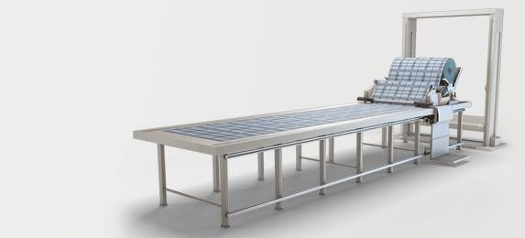
- The clothing industry is labour intensive industry.

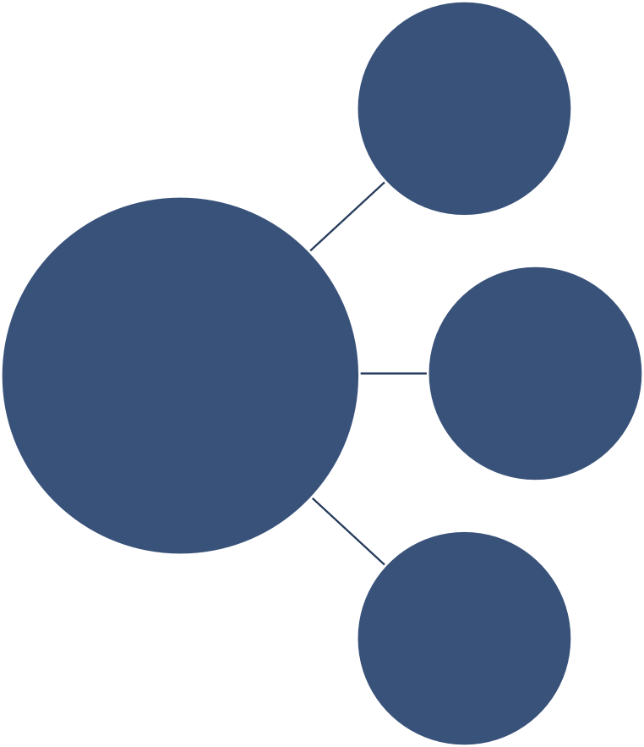
One- off
- One-off production is designing and making a
single textile product to a client's specification.
- The garment design is developed from a basic block pattern, with a Prototype made from inexpensive fabric to test the drape, fit and assembly of the garment.
Batch
- Batch production is manufacturing set
quantities of a textile product to order.
- The quantity of products can vary from a set of four cushions made by a designer-maker, to 20,000 jumpers made for a department store
Mass
- Mass production is industrial-scale manufacture
of large quantities of products, usually on a production line.
- Mass production is suitable for products that seldom need to be redesigned and are needed in very large numbers, eg socks or jeans.
One- off
Production Systems
Batch
Mass

Production system | Product market | Design and production | Skill level and cost
One-off | Made-to-measure. eg suit, wedding dress; | Made-to-measure garments are made to fit the measurements of an individual client; the garment design is developed from a basic block patterns and a toile is made to test the fabric drape, the fit and order  of assembly | Very high-level skills in design and manufacture; high-cost materials; high labour costs
One-off | Haute Couture.  eg made by fashion houses | Fashion designers such as John Galliano design Haute Couture garments  for individual clients | Very high-level skills in design and manufacture;  high-cost material and labour costs
Batch production | Ready-to-wear (RTW) designer label eg Designers at Debenhams | Garments are designed to fit a range of standard sizes and shapes.  Garment patterns are developed from a basic block using CAD. A sample garment is made up in a medium size, from the intended fabric. Once the design has been approved it is put into production in a range of standard sizes. They are sold through up-market retailers. | High-level design, pattern making and sampling skills; cost-effective materials and lower  manufacturing costs
Mass production | Mass-market retailers,. eg Top Shop | Similar production methods to batch production: garments produced in limited range of sizes; standardised production methods are used to  produce a wide range of styles. Most fashion products are batch produced in large batches eg 20,000. Some classic products like jeans are mass produced for a world market. | High-level design, pattern making and sampling skills; cost-effective materials

CAD
- USING COMPUTERS TO DESIGN AND PRESENT

- Computers are used by designers for:

- Writing documents and creating display boards, including artwork, text, spreadsheets, graphs and tables

- Putting together slide show presentations

- Digital photography and video making

- Designing and sampling

- Supplementing drawing and colouring with use of specialist fashion software, e.g. Speed Step.
Programmes used by designers:
PowerPoint, Publisher
,Word, Excel, paint


CorelDraw, Adobe illustrator, Photoshop
Specialist Fashion software- Speed Step

CAM
- Computer-controlled machines /CAM play a vital role in modern textiles production. For example, they enable :
- designs to be sent electronically to the print manufacturer and stored on computer to ease repeat printing orders.
- colours to be matched to the design, dyes weighed and dispensed and the fabric printed
automatically.

- print directly onto fabric, or transfer a design from paper to fabric using heat. This can be extremely useful when manufacturing includes hazardous and toxic processes, such as dyeing.

- load fabric onto the cutting machine and operate the cutting equipment.

- 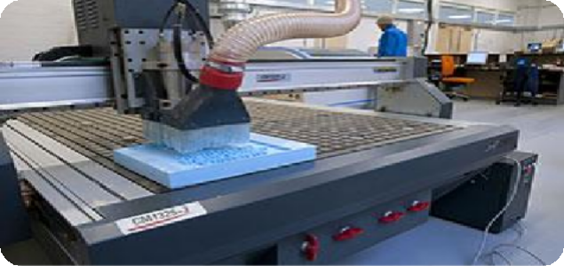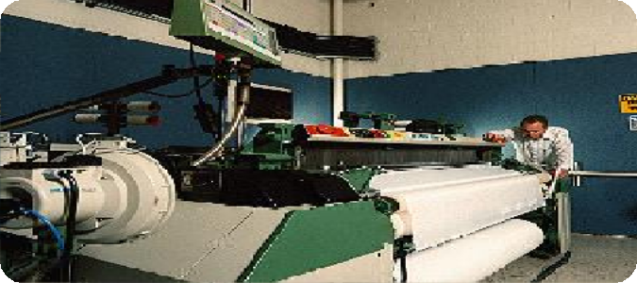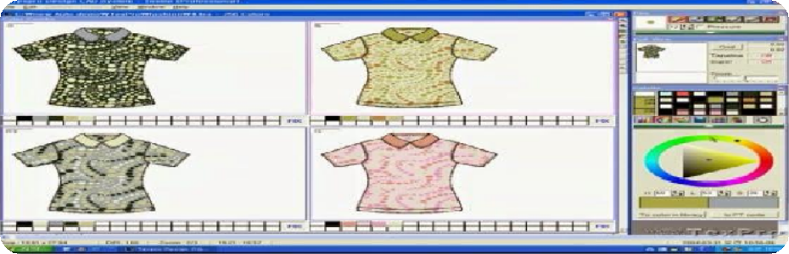stitch the pieces of fabric together – automatic sewing machines include microprocessors to control the movement of pattern pieces, and sensors which stop the machine if anything goes wrong. CAM enables batch production to run smoothly as it does not take long to reset equipment as data is stored and saved.

Production Flow
DYING PROCESSES
COTTON FIBER PRODUCTION

Dyeing Processes
WEAVING
FINISHING PROCESSES
SIZING PROCESSES

Preparation Pre- Washing
Dyeing Back- Washing
Softening

Source: http://www.textiletoday.com.bd/magazine/609

Cotton manufacturing

Cotton is the world's most important natural fibre. cultivated in more than 50 countries.
- Cultivating and Harvesting

- Preparatory Processes

- Spinning- giving yarn

- Weaving- giving fabrics

- Finishing- giving textiles

Departments in garment manufacturing unit


Merchandising
department
Sampling
department
Fabric store
department
Trims and
accessories store department
Spreading &
Cutting department
Sewing
department
Washing
department
Quality
Assurance department
Finishing &
Packaging department
Maintenance
Department
Finance and
Accounts Department
HR/Admin
Department

Source: http://www.textiletoday.com.bd/magazine/609

Process flow in garment manufacturing unit

Buyer- Supplier Meeting

Production order placed

Sampling
BOM
generation for po
Pre production sample

Fabric washing

Raw material inspection

Raw material procurement




Production
Shipment sample

Finishing

Packing

Source: http://www.textiletoday.com.bd/magazine/609

Shipment



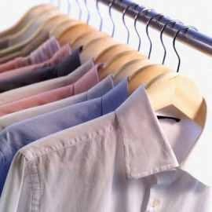
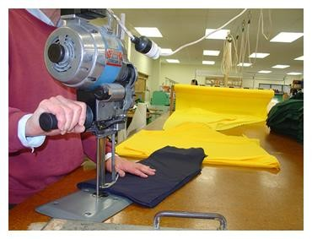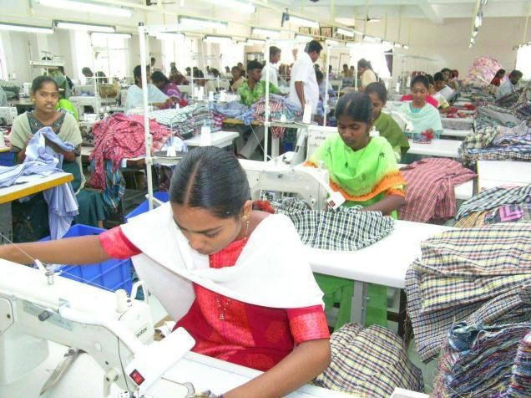

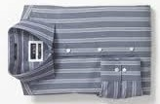

Process flow in merchandising department

















Receipt of the techpack

BOM draft for sampling

Pattern making

Raw material procurement

Raw material inspection

Proto sample development

Order approved for production

Approval sample development

BOM draft for production

Getting the fit sample approved

Fit sample making

Getting approval on proto sample
Getting approvals on size set samples

Raw material procurement

R aw material inspection
GPT/FPT to conform to standards
Approval on pre production sample
Order file transferred to the production department
Follow up with the production department till delivery
Send shipment samples to the buyer
Follow up with the production department

Responsibilities of a merchandiser

Internal & external communication

Sampling

Preparing internal order sheets

Accessories & trims

Preparing purchase orders

Merchandiser
Getting approvals on lab dips and bit looms

Advising and assisting production and quality department

Mediating production and quality departments

Helping documentation

Taking responsibility for inspections

Giving shipping instructions and following shipment

Source: http://www.fibre2fashion.com/industry-article/36/3516/merchandising-in-an-apparel-industry1.asp

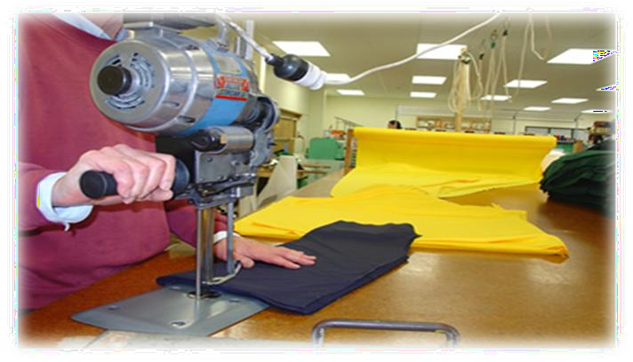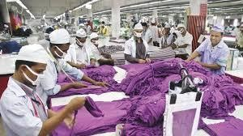



Responsibilities of sampling department

- Getting clarifications about style details from merchandiser.

- Checking pattern’s workability.

- Preparation of different samples and getting the buyer’s approval.

- Informing quality related problems, encountered during preparing samples, to QC.

- Minimizing operations and consumption.



Functions of the fabric store department

- Receive the fabric as per BOM

- Fabric inspection (four point system)

- Conduct fabric test (e.g. Shrinkage, colour fastness etc.)

- Issue to the production department as per the requirement
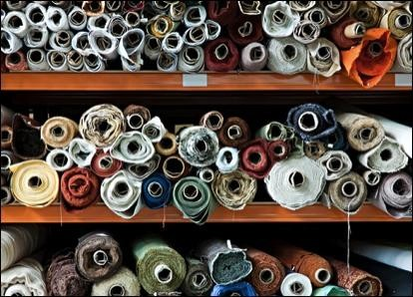



Functions of the trims and accessories department

- 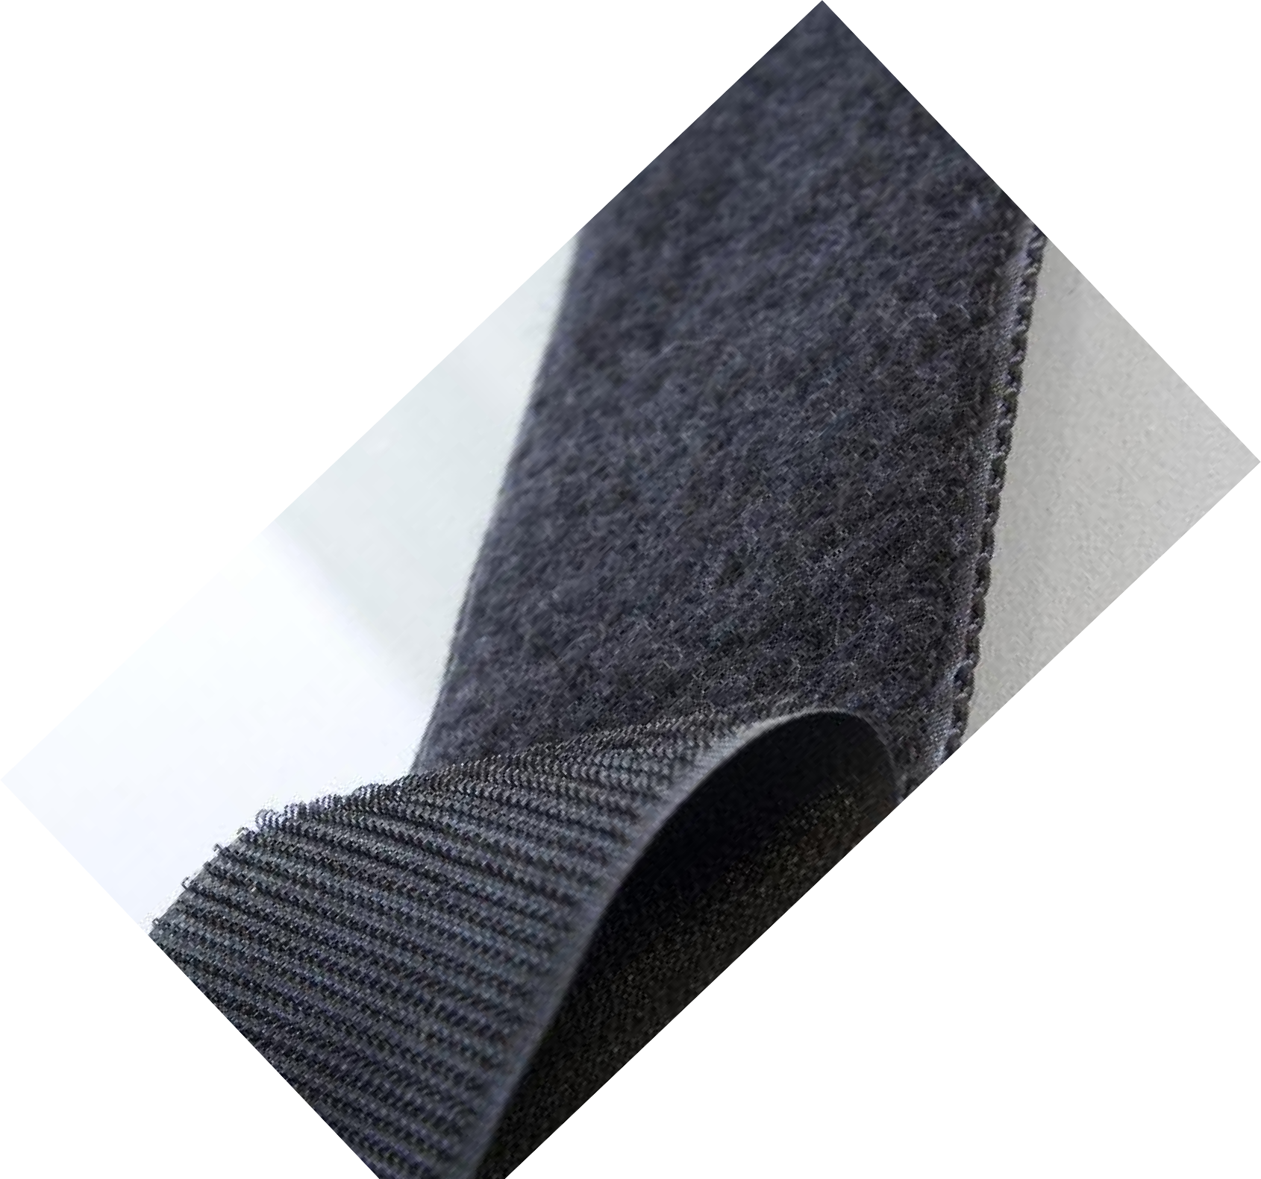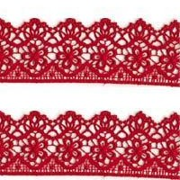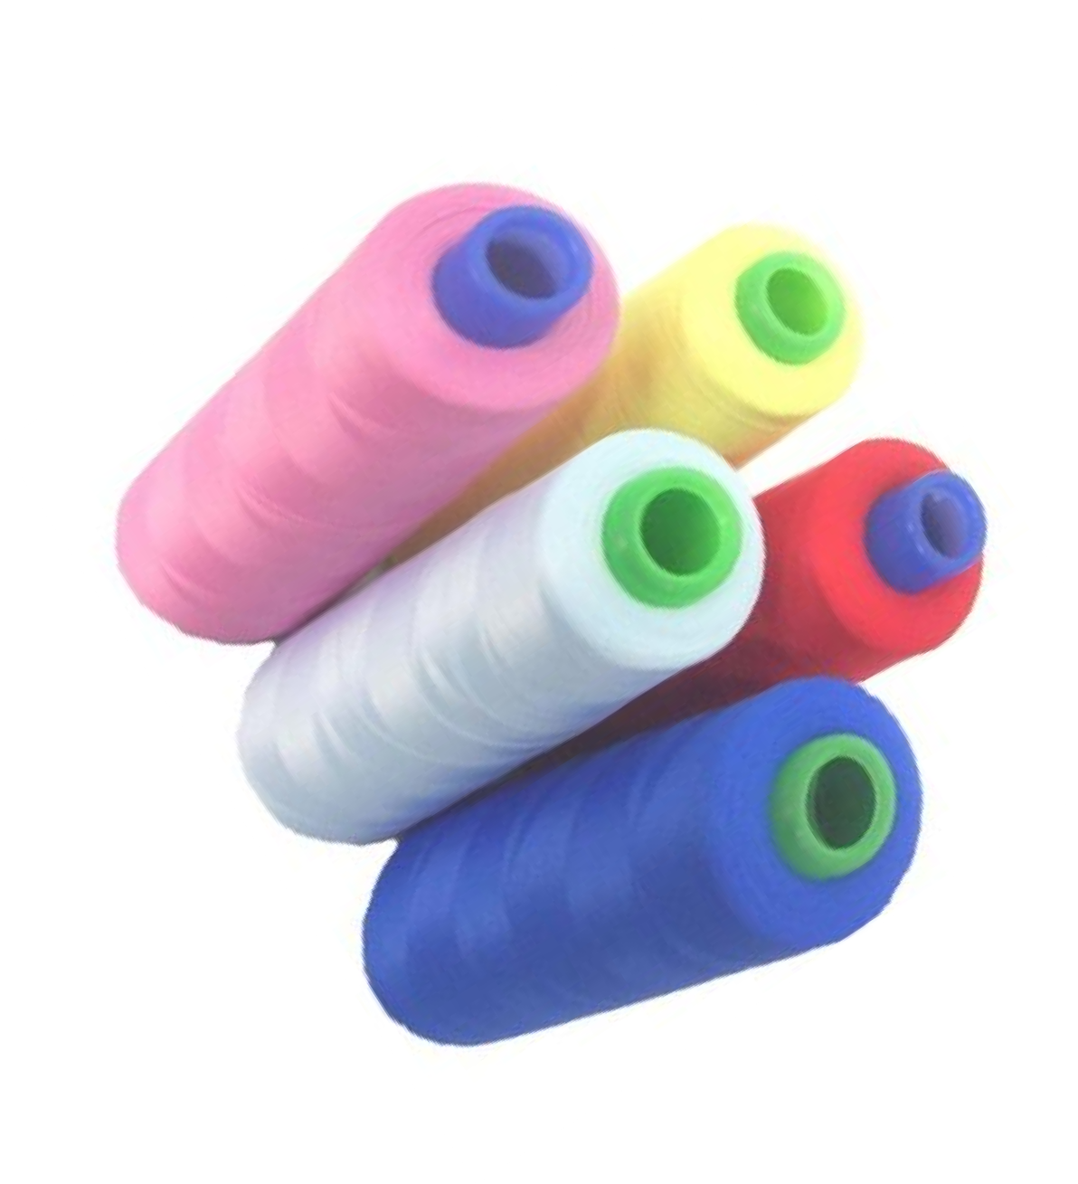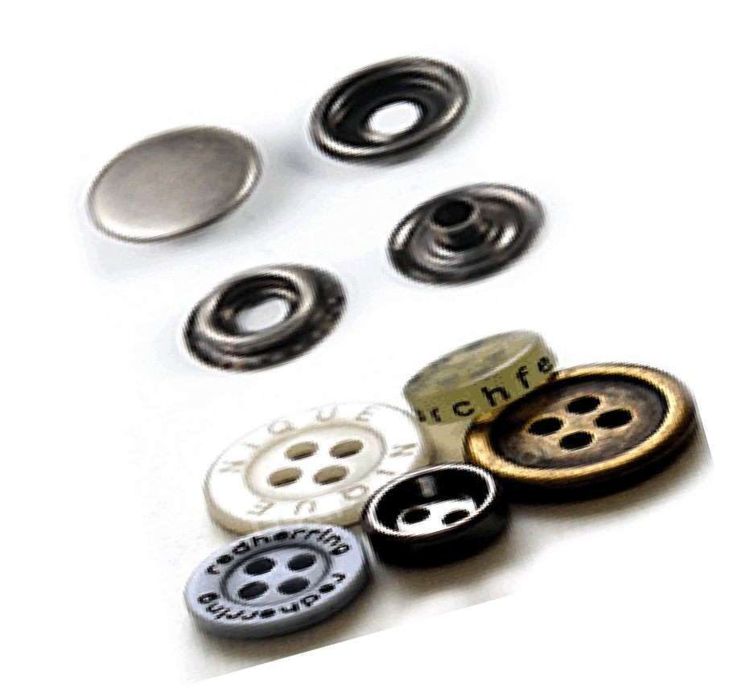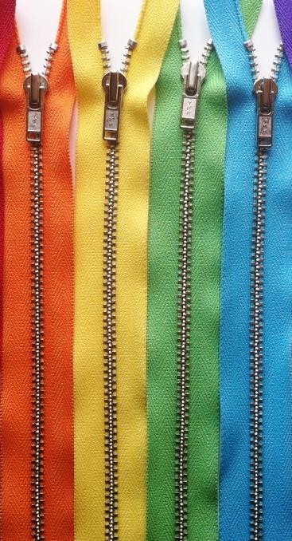To receive incoming material.

- To check material for attribute & variables.

- To arrange the incoming material in allocated racks.

- To issue trims as per BOM for sampling and production & other material as per requirement.

- To maintain a record of incoming & outgoing material.

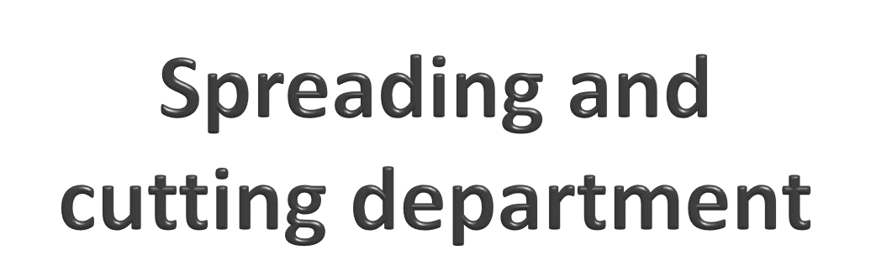

Spreading and cutting flow process

Planning Spreading Cutting Preparation for sewing

Spreading and cutting flow process

Production
Markers

Planning
Spreads
Machine

Spreading
Manual
Machine

Cutting
Manual
Bundles
Preparation for sewing
Ticketing

Marker

- is a diagram of a precise arrangement of pattern pieces for a specific style and the sizes to be cut from a single spread.

Marker making

- is the process of determining the most efficient layout of pattern pieces for a specified style, fabric, and distribution of
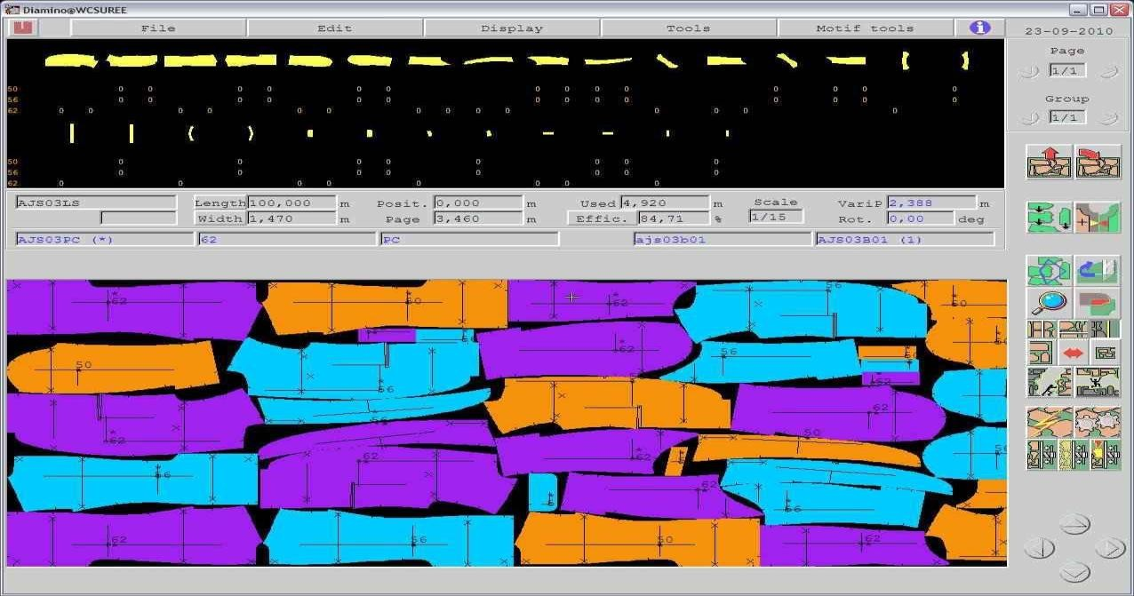
sizes (requires time, skill and concentration)

Spreading
- Spreading is the processes of superimposing lengths of fabric on a spreading table cutting table or specially designed surface in preparation for the cutting process

- Spread or lay is the total amount of fabric prepared for a single marker

Requirement of spreading
  - Shade sorting of cloth pieces
  - Correct ply direction and adequate lay stability
  - Alignment of plies
  - Correct ply tension
  - Elimination of fabric faults
  - Avoidance of distortion in the spread

Spreading equipment

  - Spreading surfaces ( table, pin table, vacuum
table)
  - Spreading machines

Spreading equipment
Spreading

- Spreading surfaces ( table, pin table, vacuum table)
- Spreading machines

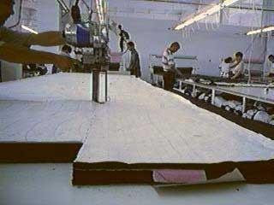
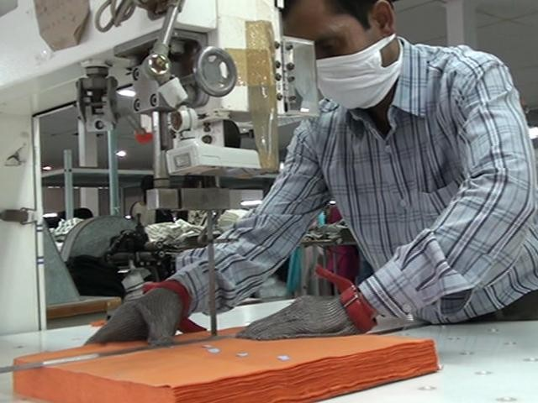
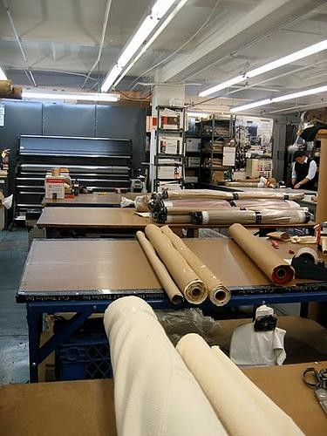
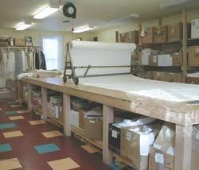


Cutting

Cutting

Manual

Scissors

Portable cutting
knives

Straight knife

Round knife

Machine

Stationary cutters
Band knife
Die
cutting
Servo cutting
Plasma cutting
Water jet cutting
Laser
cutting

Position markers

Notchers

Drills and thread markers

Cutting

Portable cutting knives

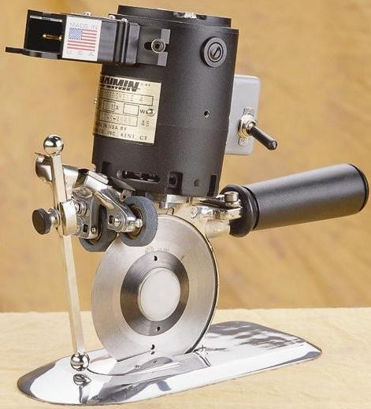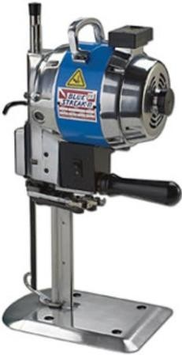Power system

Handle

Sharpening

Cutting blade

Blade guard
Up and down movement

Round knife
One way thrust as the circular blade makes contact with the fabric

Base plate

Straight knife



Sewing process flow














Cut parts received from the cutting room

Bulk production
begins

In line inspection

Production continues

End line checking

Measurement checking

Final checking

Ironing

Rough checking

Button-button hole/ bartack

Tagging

Packing

QA audit by the
buying house

Ex - factory



Machine beds

Raised bed Flat bed
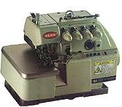
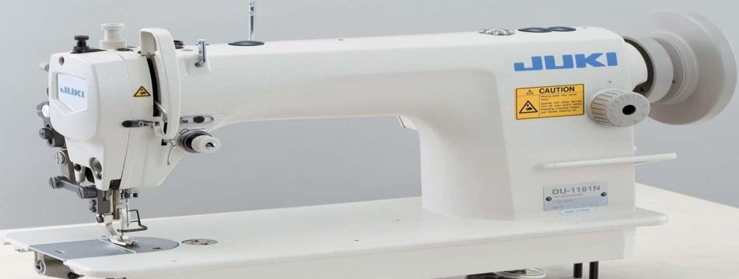

Feed of arm Post bed
Cylinder bed
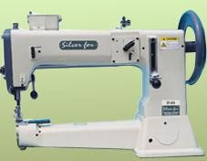

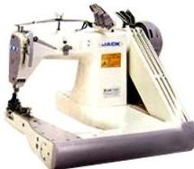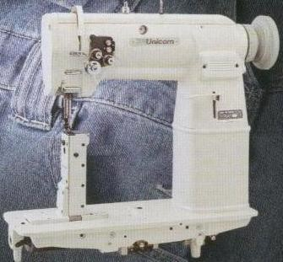

Source: Glock & Kunz (Third edition)



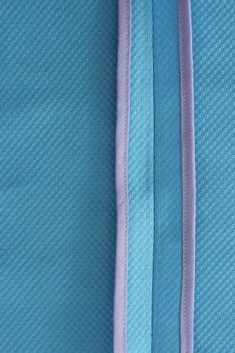Classification of seams
Bound seam
  - Superimposed seam

Superimposed seam

  - Lap seam

  - Bound seam

  - Flat seam
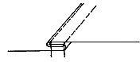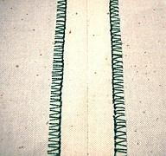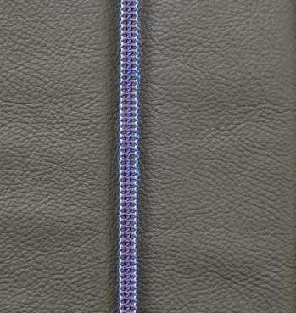
- Edge finishing
Lap seam

Edge finishing
Flat seam

Source: Glock & Kunz (Third edition)

Stitch classification
- Stitch classification is based on structure of the stitch and method of interlacing.

100 Class stitch: Single thread chain stitch
200 Class stitch: Single thread hand sewn stitch
300 Class stitch: Two or more thread lock stitch
400 Class stitch: Multi-thread
chain stitch
500 Class Stitch: Multi-thread over edge chain stitch
600 Class Stitch: Multi-thread cover stitches
- Using needle thread(s) and looper thread(s)
- Using one or more needle threads and one or more
looper threads
- Using Needle Thread(s) and One Bobbin Hook Thread
- Using one needle thread
- Using one needle thread and one blind looper

Source: Glock & Kunz (Third edition)





Responsibilities of quality department

- To impart quality in the product.

Quality department

- To ensure that the product has achieved the quality parameters of buyers.

- To restrict the defects entering into the final product.

- Main function of quality department is to carry out inspection.

- Inspection can be defined as the visual examination or review of raw materials, partially finished components of the garments and completely finished garments in relation to some standards, specifications, or requirements, as well as measuring the garments to check if they meet the required measurements.

Source: P. B. Mehta and S. K. Bhardwaj, “ Managing quality in apparel products”



Principle of inspection (inspection loop)




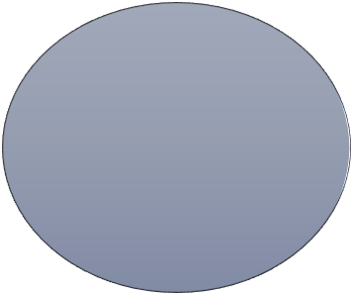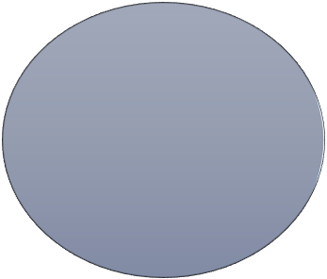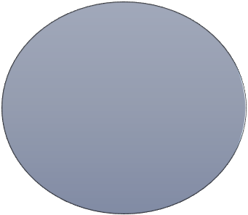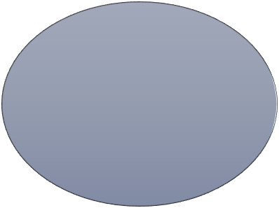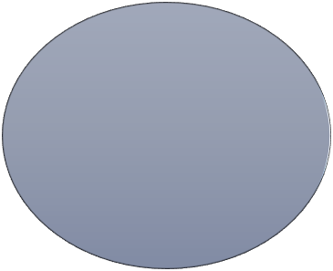
Inspection
Correction of
defects
Detection of
defects

Determination of causes of defects

Feedback of these defects to appropriate personnel

Source: P. B. Mehta and S. K. Bhardwaj, “ Managing quality in apparel products”

Checks for final inspection
- Open seams

- Skipped stitches

- Cracked stitches

- Stitches/inch

- Uneven seams

- Crooked, puckered, curled, pleated seams

- Needle and feed cuts

- Unclipped threads and Long ends

- Raw edge

  - Snaps, fasteners, buttons
  - Labels
  - Elastic
  - Measurements
  - Mends or repairs
  - Stripe
  - Hems
  - Trim
  - Broken needle
  - Distortion

Source: P. B. Mehta and S. K. Bhardwaj, “ Managing quality in apparel products”

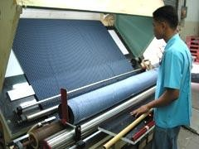
Fabric audit procedure
- ~10% random inspection for sampling or lining or net fabric.

- Inspection for production order fabric as per buyer’s requirement.

- Perform GSM cutting.

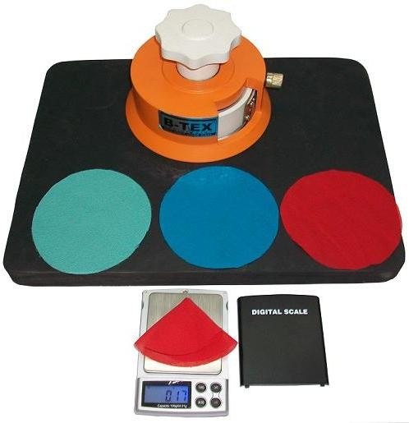
- Perform shrinkage test.

- Check the fabric for the bowing or skewing.

- Check fabric roll for the defects.

- Allocate points to the defects.
The fabrics are checked for:
- Width
- Shade (centre to selvedge)
- Weaving defects
- Shrinkage (steam & fusing)



Finishing and packaging department
- Finishing is the last stage of garment production where garment gets its final look.

- In this department each garment undergoes different finishing processes.

- It undergoes for quality check for several number of time which sets the garment free from defects.

- Buyer specifications and instructions are strictly maintained.

Source: P. B. Mehta and S. K. Bhardwaj, “ Managing quality in apparel products”

Finishing and packaging department

Operations performed at finishing stage

- Thread cutting: Uncut threads affect the presentation of finished and packed garments. Therefore, it is necessary to cut and trim the loose and uncut threads.

- Stain removal: Removal of the following type of stains:
Oil, yellow, black and paint spots, stains due to color bleeding, ink, rust, tracing marks, yellow stains, and hard stains
- Seam ironing: Ironing of garments using steam ironing tables with vacuum boards.

- Final finishing: The entire garment is finished using various finishing equipments.

Source: P. B. Mehta and S. K. Bhardwaj, “ Managing quality in apparel products”

Corporate positions

  - Corporate Sourcing head

Positions in Textile industry
Plant and Store Positions

    - General Manager Quality

Sales and Marketing Positions

  - HR Manager

  - Manager – Accounts and Finance

  - IT Operations Manager

  - Divisional Merchandising Manager

  - Senior Manager compliance.-
Textiles

  - Head Visual Merchandising

  - Head Taxation

  - Fabric sourcing manager

  - Senior manager engineering

  - Senior Production Manager

  - Warehouse- Incharge

  - Manger - Velvet Weaving

  - Senior Merchandiser

  - Weaving & PPC Head

  - Spinning Manager

  - Technical Specialist - Dyes And chemicals

  - Head of Dye House-Knit Fabrics
  - Marketing Head(Apparel &
Textile)

  - Senior Regional Sales Manager

  - Brand Manager

  - VP Sales Exports

  - Manager-Institutional Sales

R&D Positions

  - Head Designer

  - Manager- Design & Product

  - Creative Head

  - General Manager Product development



